1. Problem Statement
Evaluate a university candidate using subject eligibility, aggregate marks, and course-specific thresholds to determine if they are admitted.
2. Objectives
- Accept student marks in three core subjects and aggregate percentage.
- Check against minimum cutoff criteria using simple if-else conditions.
3. Assumptions
- Minimum aggregate required is $75\%$.
- Minimum mark in Mathematics must be $70$.
4. Algorithm
- Start.
- Read student name, math marks, physics marks, chemistry marks, and aggregate marks.
- Check if aggregate $≥75$ AND math marks $≥70$.
- If true, print "Admitted"; else print "Not Admitted".
- Stop.
5.Flowchart
[Start]
--> [Input Student Details: Name, Math, Physics, Chemistry, Aggregate]
--> [Check Condition: Aggregate >= 75 AND Math >= 70]
--> {Are conditions True?}
├── Yes --> [Print: Student is ADMITTED] --> [Stop]
└── No --> [Print: Student is NOT ADMITTED] --> [Stop]

6. Pseudocode
- START
- PRINT "Enter Name:"
- READ name
- PRINT "Enter Math Marks:"
- READ math
- PRINT "Enter Physics Marks:"
- READ phy
- PRINT "Enter Chemistry Marks:"
- READ chem
- PRINT "Enter Aggregate Percentage:"
- READ agg

- IF agg >= 75 AND math >= 70 THEN
- PRINT name, "is ADMITTED to the course."
- ELSE
- PRINT name, "is NOT ADMITTED."
- ENDIF
- STOP
7. Python Source Code
print("=== University Admission System ===")
name = input("Enter student name: ")
math = float(input("Enter Mathematics marks (out of 100): "))
phy = float(input("Enter Physics marks (out of 100): "))
chem = float(input("Enter Chemistry marks (out of 100): "))
aggregate = float(input("Enter overall aggregate percentage: "))

if aggregate >= 75 and math >= 70:
print("\nCongratulations", name, "! You are ADMITTED.")
else:
print("\nSorry", name, ". You are NOT ADMITTED.")
print("Reason: Aggregate must be >= 75 and Math marks must be >= 70.")
8. Test Cases & Output Log
- Test Case: Name: Amit, Math: 85, Physics: 80, Chemistry: 78, Aggregate: 81 $→$ Output: Admitted.
- Log:
=== University Admission System ===
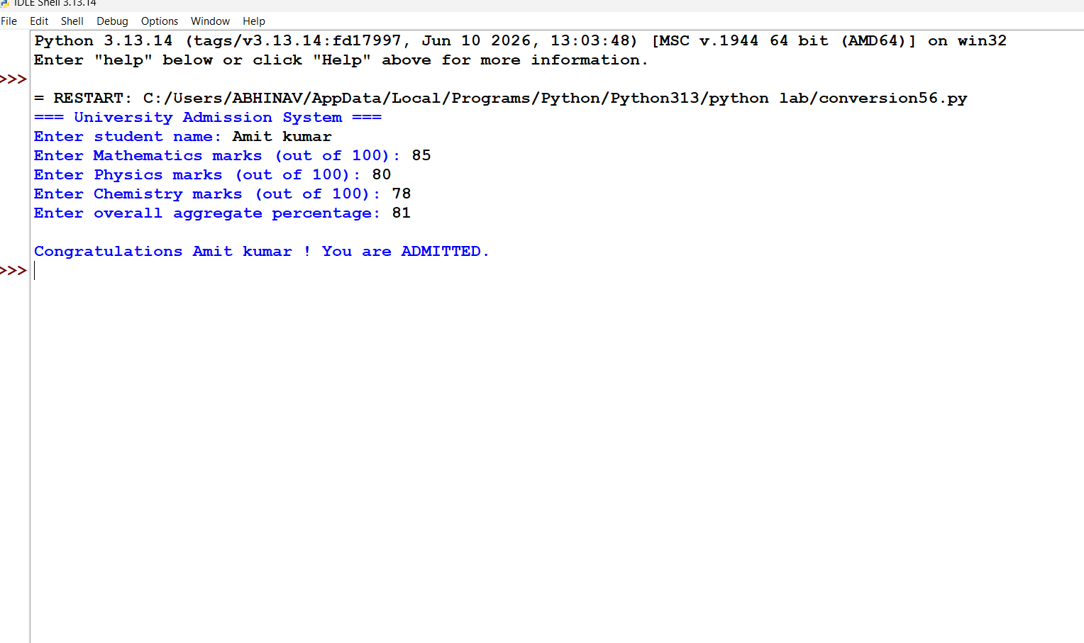

Conclusion: Successfully built a decision engine using foundational if-else branching to verify candidate course-specific subject cutoffs and aggregate benchmarks for university admissions.

